Transactions:
Bitcoin transactions transfer bitcoins on the network and are conglomerated into blocks. A transaction takes in inputs as previous transaction outputs and sends all input bitcoins specified in the transaction to new outputs. They are not encrypted so they allow public viewing of the details of a transaction.

-a transaction is devided into three categories, metadata, input and output
- metadata, contains the hash of the transaction, and other information
- input contains hash of previous transaction, and the index of the ouput of that transaction you are claiming, and signature allowing th recipient to claim the bitcoins in the previous transaction.
- Output has a value which is less then the sum of all the inputs. The sum of the outputs needs to be less than the sum of all the inputs, the remaining is giving to miners as a transactio fee. Then there is also a hash of the recipients public key, along with the public key there is a script with Opcodes.
Source: https://www.coursera.org/learn/cryptocurrency/lecture/neykl/bitcoin-transactions

Bitcoin uses a scripting language rather the simply assigning a public key as the recipient. The output address is esentially a script with specific instructions. The script tells specifies who is able to spend the provided coins. The input address is a script and the output address is also a script. They are concatinated and run and if the result is true then bitcoins are sent. The simplest most commonly used script In bitcoin to redeem a previous transaction by signing with a public key.
The two scripts which are concatinated into one consisting of scriptSig(input), which specifies a signature with a public key and scriptPubKey(output) which specifies that pulic key. The two scripts are concatinated together and if they run with no errors, the transaction is valid.

-a script are a series of commands within a file which are interpreted by another program (not compiled)
Bitcoin’s scripting language is stack based with no loops (each instruction is executed once procedurally). Not turing complete, these scripts are generated by people to be run and executed by bitcoin miners where miners don’t want to run scripts with infinite loops and other sophisticated functions provided by a turing complete language. A bitcoin script runs in finite time. Data is pushed onto the stack (writing data to memory), the bitcoin script produces a boolean outcome, false if script fails hence not a valid transaction, and true if script runs without error meaning the transaction is valid.
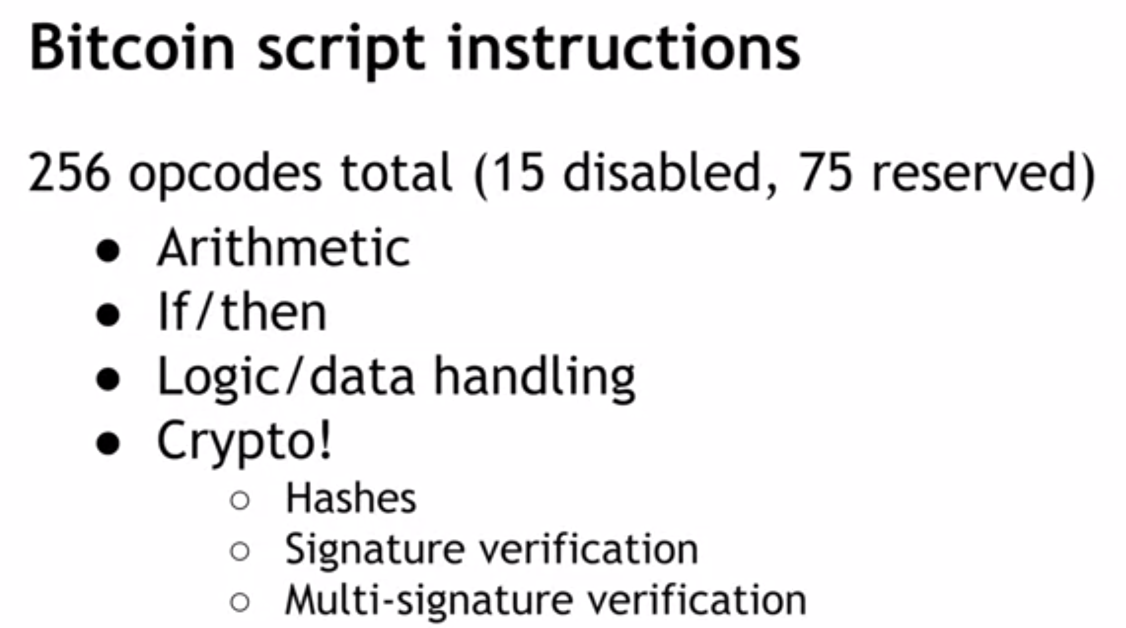
The bitcoin scripting language also allows you to check multiple signatures with a single instructions, known as OP_CHECKMULTSIG. You would specify n public keys and a threshold t where t is the minimum number of valid signatures needed to be a valid transaction.

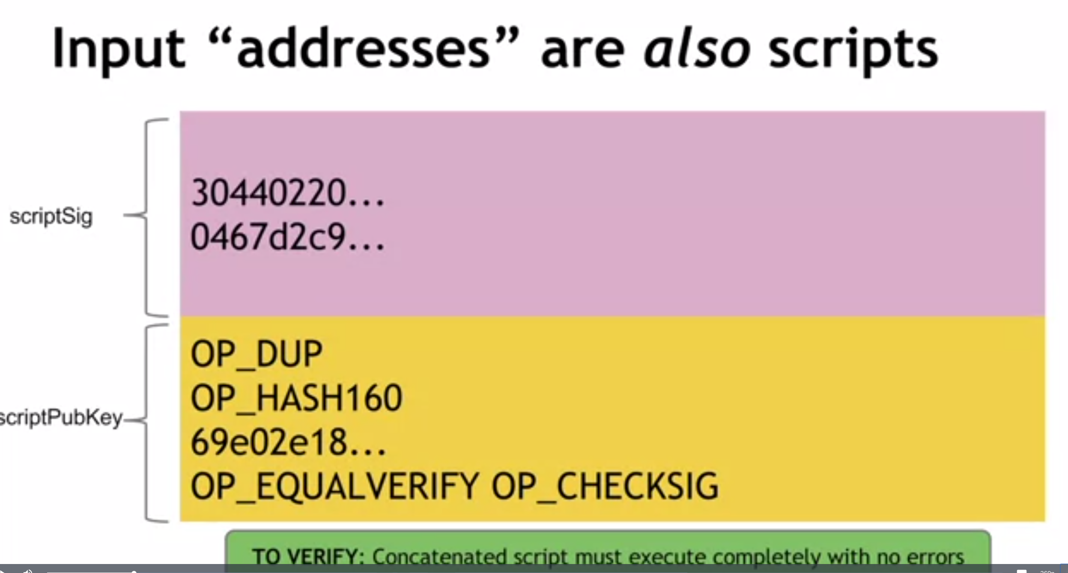
An example of how the scripting language works. The most commonly used script:
<sig> <pubKey> OP_DUP OP_HASH160 <pubKeyHash?> OP_EQUALVERIFY OP_CHECKSIG
-<> is data to be pushed on to the stack, OP_ are opcodes(instructions) to manipulate data on the stack.
- this script is where the sender specifies the public key of the recipient and the recipient (in order to redeem the coins) specifies the signature with that public key.
-the first two data values are specified by the recipient in scriptSig(input) component, where sig is the signature and pubKey is the recipients public key used to generate the signature sig.
<sig> <pubKey> OP_DUP OP_HASH160 <pubKeyHash?> OP_EQUALVERIFY OP_CHECKSIG
Stack overview per above script instruction:
NOTE: <sig> <pubKey> is the scriptSig component provided by the recipient
Step1: <sig>

Step2: <pubKey>
<sig>
NOTE: OP_DUP OP_HASH160 <pubKeyHash?> OP_EQUALVERIFY OP_CHECKSIG is the scriptPubKey component provided by the sender of coins.
-now we manipulate data on stack, OP_DUP duplicates the last item on stack
Step3: <pubKey>
<pubKey>
<sig>
-OP_HASH160 preforms a hash of the last next item on the stack and converts it into this hash
Step4: <pubKeyHash>
<pubKey>
<sig>
-next we push the public key specified by the sender in the data segment <pubKeyHash?> which is the public key specified by the sender as the address that must be used.

Step5: <pubKeyHash?>
<pubKeyHash>
<pubKey>
<sig>
-on the stack there is now the public key of specified by the sender and the public key specified by the recipient OP_EQUALVERIFY checks if they are the same and removes them from the stack, if true the script will continue running else, the script will stop and exit.
Step6: <pubKey>
<sig>
-so far the public key was checked where the sender specified recipients public key matches the recipients public key, no OP_CHECKSIG checks if the specified signature is correct (as specified by the recipient). The signature <sig> is a signature of the entire transaction, this opcode checks if the transaction was a valid signature.
Step7: //stack is empty
-if no errors, transaction is valid, else it is not valid and the script exits.
Source: https://www.coursera.org/learn/cryptocurrency/lecture/HWjti/bitcoin-scripts

These scripts are incorporated into the data of a raw transaction which is the double hashed to create the transaction ID or transactio hash which is used in the merkle tree to produce the merkle root as well as a reference to the transaction in the blockchain.

Transactions Continued:
-each transaction has a 4 byte version number specifying bitcoin version.
-each transaction has at least one input and has one output. Inputs spend satoshi’s (100000000satoshi’s = 1 btc ) from a previous output. Each output waits as Unspent Transaction Output (UTXO) until a later input spends it.
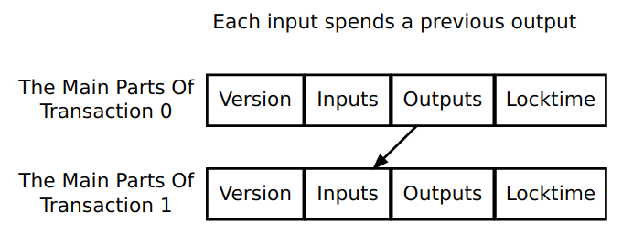

-an output contains an index where it exists in a transaction, first output is zero. The output also has an amount of satoshis to spend and it can only be spend using a conditional script: scriptPubKey, this script must return true in order to spend satoshis. Someone who satisfies the script is able to spend the satoshis
-inputs have a transaction identifier (txid) and output index (vout). This is used to identify a particular output to spend. An input also contains a script: scriptSig which is used to satisfy and hence spend the satoshi’s in the scriptPubKey.
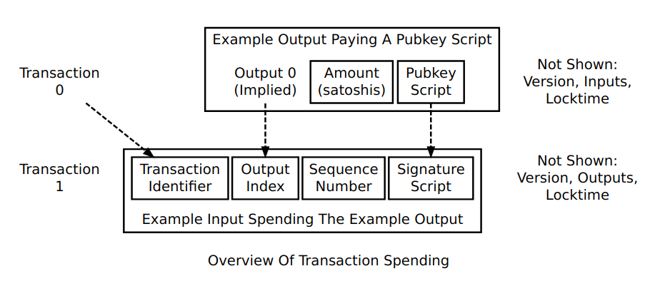

The scriptSig and scriptPubKey are concatinated and ran together to check the validity of the transaction.

Bitcoin transactions come in a few different types, first off there is a coinbase transaction which is a unique type of transaction, and the most commonly used transaction is the Pay-To-Public-Key-Hash (P2PKH), this type allows alice to spend satoshi’s to a public bitcoin address and then have Bob spend those satoshis using a signature and his public key.

This type of transaction is preformed via the following order. Bob generates a public/private key pair using the ECDSA with the secp256k1 curve. Bob hashes his public key and sends it as a bitcoin address to Alice. The bitcoin address contains the public key hash, address version number, checksums to check for typos and this is all in base 58.

From here Alice decodes the address back into the public key hash. She then creates a transaction by generating the standard P2PKH output which contains the scriptPubKey instructions for Bob’s public key. This means someone who is in control of Bob’s private key can spend the funds by providing a signature of this transaction (using only bob’s private key) along with Bob’s Full public key as scriptSig. Alice then broadcasts the transaction to the network which is added to the blockchain (if alice’s provided scriptSig + (her previous transaction’s)scriptPubKey returns valid). And now Bob has more unspent satoshis waiting to be spent.

When Bob wants to spend his satoshi’s he generates an input which references a previous output from a Alice’s transaction by the transaction hash (txid) and the specific output she used by its output index number. He must also provide a scriptSig which satisfies the conditions Alice placed on the previous scriptPubKey instructions. From Bob’s new transaction, the scriptSig is concatinated with the scriptPubKey from the referenced output transaction (alice’s transaction) and run by the miners to validate the transaction before adding it to a block. If valid the recipient of bob’s bitcoins will now have new unspent bitcoins added to his balance.

-In Bob’s new transaction, the scriptSig will contain his full unhashed public key so that it can be checked if it hashes to the same hash provided by alice in the scriptPubKey. The scriptSig will also contain a signature of the data of the txid and output index of previous transaction being referenced, previous outputs scriptPubKey, the new scriptPubKey Bob creates for next recipient, and the amount of satoshi’s spend to the recipient. The signature is essentailly the whole new transaction signed with bob’s private key except any scriptSig parts. This signature proves that Bob for one is the owner of the public key as well as enures that the non-signature components of the transaction are tamper-proof.

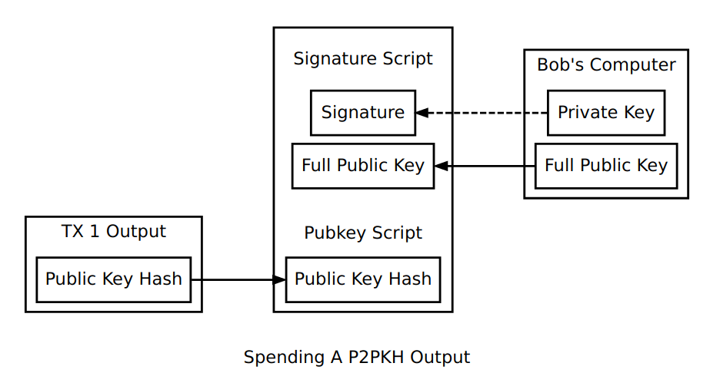

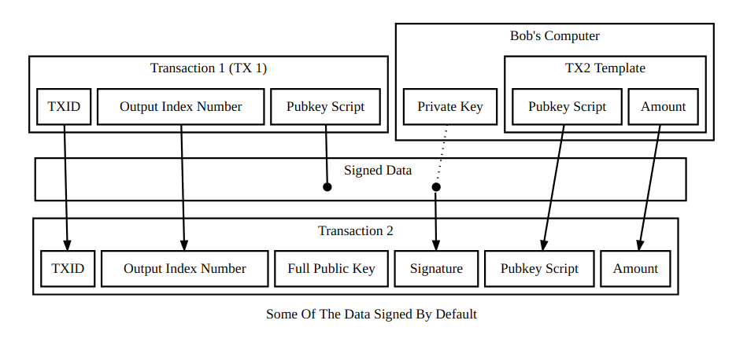
Source: https://bitcoin.org/en/developer-guide#transactions

